Plant Survey Program 2023 – 2024

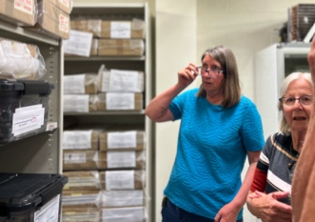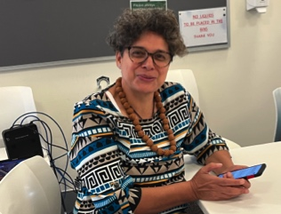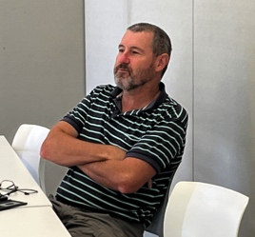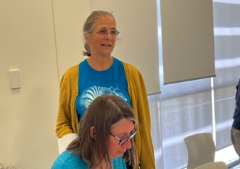
Figure 1: Plant survey people (from left to right) Jolanda(standing) and Margaret Langley; Clare Caldiera; Margaret and Kaye Kelly; Glenn Cook. Jolanda, Margaret, Clare and Glenn are on the Management group for the program as well as Brian Moyle, Geoff Corrick and Greg and Bronwen Keighery.
This program has two components–Bushland Plant Survey (plant communities) and Priority Flora Survey (rare plants). Both parts
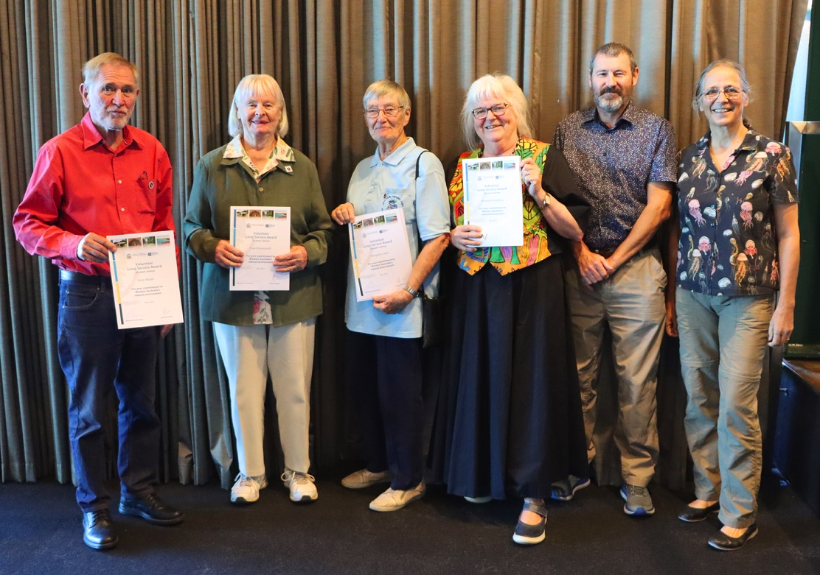
Figure 2: Survey people at the Moring Tea (from left to right) Brian, Fran Kininmonth (25 years in the WA herbarium group), Margaret, Bronwen with guests Glenn and Jolanda.
Both of these programs are registered with the Department of Biodiversity, Conservation and Attractions (DBCA). The Bushland Plant Survey has been registered for more than 30 years and the Priority Flora Survey since its inception four years ago. As a consequence, a number of volunteers from the Society were recognised in Volunteer Week on 23rd May 2024 for long service to DBCA. There were three categories recognised: 20, 25 and 30 years. People from the program who were recognised included the following.
30 years–Margaret Larke and Brian Moyle; and
20 years–Anne Gunness, Bronwen Keighery and Alice Stubber,
Other Society members were present having a long term commitment to a series of DBCA Volunteer Programs.

Bushland Plant Survey

In the Herbarium

Attendance on Wednesdays at the Reference Herbarium in Kensington has been consistent, productive and cheery. We have been fortunate with more than 20 volunteers contributing to the project’s sessions on a regular basis, not much changing over the years. Wednesday support from Margaret Langley, Jolanda Keeble and Greg Keighery is much appreciated by the group. Margaret, our DBCA representative, has been helping with identification and database training. One Wednesday volunteer has become a regular volunteer databaser, databasing all the current survey work. This year we had several new volunteers showing an interest in assisting the regular Wednesday group. Unfortunately, most of them have a full time job and are therefore irregular contributors.
When it looked like we had caught up with our work load for the year, we could always find some more specimens tucked away in the botany store, or Jolanda wanted some help with her Wongan Hills specimens. Thanks to Margaret Langley, Bronwen Keighery and Jolanda Keeble for keeping the volunteer group going and the work interesting.
Our annual Christmas gathering was sponsored by DBCA in recognition of our voluntary work. Thanks DBCA.
In 2023 our group of volunteers has sorted and identified hundreds of plant specimens from: Julimar; and various locations in the Wheatbelt and contributed 1955 hours. Work in 2024 has included: progressing identifications from Wattle Road in Neerabup (from plots placed in 2004); Wheatbelt Woodlands Field Herbarium; and we plan a Swan Coastal Plain Tammala Limestone Field Herbarium from the Wattle Road specimens.

Thanks to the DBCA Herbarium for continuing support.

In the bushland
In 2023 we continued surveys in the Julimar State Forest and Bijebup Reserve (near Gracetown). These surveys will be continued in 2024.

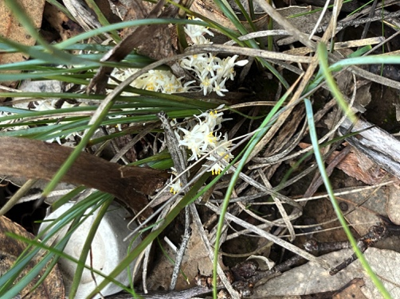
Julimar
Figure 3: Lomandra effusa, a common wheatbelt plant in the eastern Wandoo Woodland at Julimar.
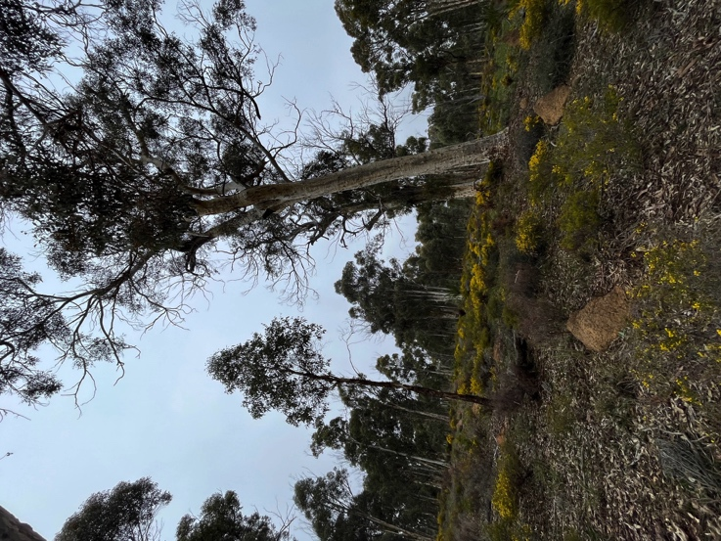
The Julimar survey was carried out over one day in September with planned herbarium sessions in November. Around 8 volunteers assisted with setting up 5 quadrats. These surveys were made possible with a grant from the Mary Bremner Bequest program. Greg and Bronwen Keighery are the botanists supporting this project. Some of their time is funded by the grant. One field day is planned for 2024.

Biljedup
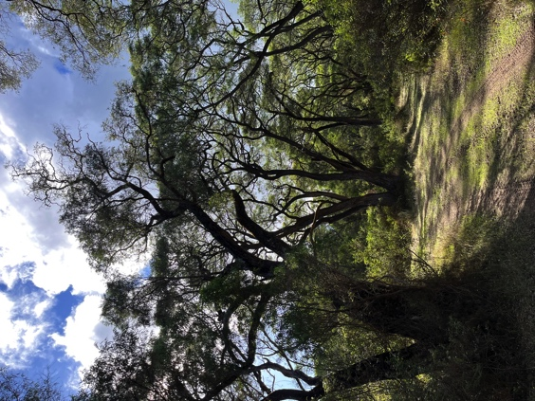
Survey on this reserve near Margaret River is coordinated by John Hill from the SW Capes Branch. In October 2023 around 10 volunteers set up four 10x10m quadrats and a 10x20m track transect. The quadrats were in Jarrah/Marri forest and Banksia woodland, and the transect section was a seasonally inundated wetland. Throughout the year, some of these volunteers carried out monthly walks, to search for plant species in this 250 ha of bushland. Andrew Webb from DBCA assisted with the identification of collected plant species.
Figure 4: eastern wandoo Woodland at Julimar.

In 2024 we are also looking at and an area about an hour north of Perth and a bushland area on the coast in the Shire of Nannup. If you wish to receive the 2024 program please contact Jolland at http://plant.survey@wildflowersocietywa.org.au .

Figure 5: Peppermint Forest in the Shire of Nannaup
THANK YOU: Thanks to all volunteers and botanists who assisted us this year.
Ongoing Projects
- Revision of manual– Keighery BJ 1994a Bushland Plant Survey. A guide to plant community survey for the community. Wildflower Society of WA, Nedlands, WA
- Nomination Prime Minister’s Science Award 2024

Priority Flora Surveys

In 2023 we carried out surveys for 6 priority flora species as outlined below. The reports on these surveys were presented on the February 2024 Society Newsletter.

- Brachyloma delbi survey (P1) in the Kulin area in May 2023 with 3 volunteers – 35 hrs.
- Pimelea pelinos (P1) in the Esperance area in June 2023 with 6 volunteers – 60 hrs and in the Shire of Kent by 1 volunteer – 6 hrs.
- Conospermum galeatum (T) in the central Wheatbelt area in September 2023 with 9 volunteers – 80.5 hrs
- Drosera lasiantha (P2) and Hibbertia porongurupensis (P4) in the Porongurup Range in October 2023 with 17 volunteers – 237 hrs (photo below)
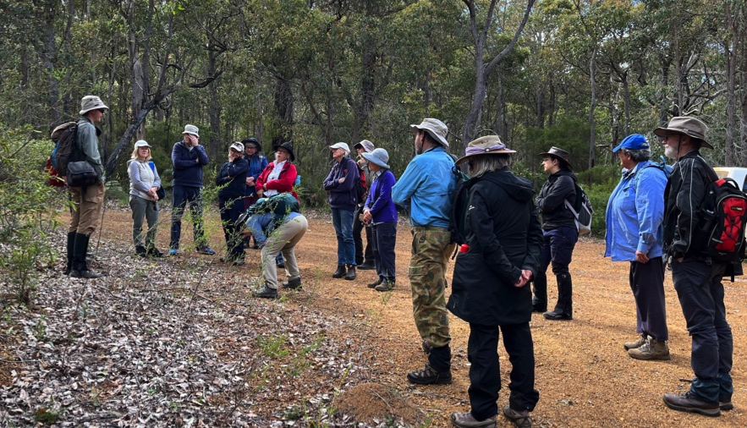
Figure 6: Group at Porungurup Range. Photo Kim Dravnieks
Total volunteer hours contributed to these surveys is 412 hours. Some surveys were more successful than others due to the lack of rain this year. Two surveys planned in the Geraldton area were postponed till 2024 due to the lack of rain, and a survey planned in the Gillingarra area was cancelled due to lack of access to the survey site.

In 2024 we are in to the fourth year of this project. These surveys continue to attract more and new Society members to go out in the bush to look for a particular plant, to learn more about our flora including some of our most threatened species, help ensure the protection of species by working to have them elevated from Priority to Threatened (or denoted to a lower Priority status), and have a good time with other members. The DBCA Flora Conservation Officers who assist with these surveys are very appreciative of the effort the Society members put into these surveys.

The 2024 program has just been released. This year we plan to carry out 8 flora surveys in 5 WA regions: Geraldton, Central Wheatbelt, Southern Wheathbelt, Perth Hills and Esperance. The intent of these surveys is to try to shift the status of the species either to Threatened or to a different priority level.
The species and dates selected for this year are:
- Pimelea pelinos (P1) in the greater Esperance area on Sunday 14 July.
- Eutaxia andocada (P1) in the greater Esperance area on Sunday 1 September.
- Grevillea minutiflora (P1) in the Mukinbudin area on Fri 6 and Saturday 7 September.
- Pimelea cruciata (P1) (and Jacksonia debilis (P1)) at North Tarin Rock on Saturday 21 & Sunday 22 Sept.
- Geleznowia eximia (P1) in the Northampton/Port Gregory area TBA in November
- Ozothamnus vespertinus (P1) and/or Ptilotus chortophytus (P1) TBA in the Port Gregory area in November/October
- Drosera silvicola (proposed P1 or P2 listing) in the North Bannister area on Sat 9 November and Paruna Wildlife Sanctuary on Sun 10 November.
- Eremophila sp. Kulin (P1) in the Kulin area on Monday 7 & Tuesday 8 October (limited numbers only).

For surveys in the Geraldton area exact dates have not been set. If you register your interest in these surveys I will let you know as soon as they are available. If you have not been sent the program and would like to find out more or want to register your interest, please email Jolanda Keeble at rare.flora.surveys@wildflowersocietywa.org.au.

Bronwen Keighery and Jolanda Keeble

